**Unit 4 – Congestion Control and Quality of Service**

The main focus of congestion control and quality of service is data traffic. In congestion control we try to avoid traffic congestion. In quality of service, we try to create an appropriate environment for the traffic.

***Data Traffic***

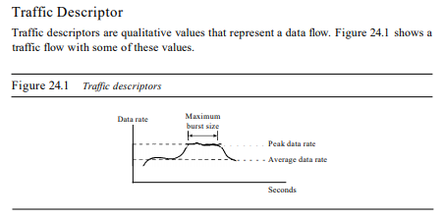

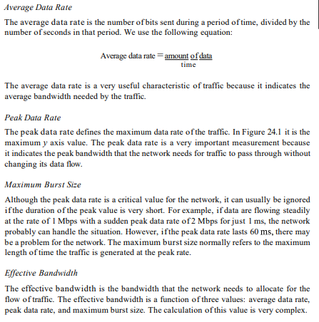

Traffic Profiles:

**Constant Bit Rate** A constant-bit-rate (CBR), or a fixed-rate, traffic model has a data rate that does not change. In this type of flow, the average data ratc and thc peak data rate are the same.

**Variable Bit Rate** In the variable-bit-rate (VBR) category, the rate of the data flow changes in time, with the changes smooth instead of sudden and sharp. In this type of flow, the average data rate and the peak data rate are different.

**Bursty**: In the bursty data category, the data rate changes suddenly in a very short time. It may jump from zero, for example, to 1 Mbps in a few microseconds and vice versa. It may also remain at this value for a while. The average bit rate and the peak bit rate are very different values in this type of flow. The maximum burst size is significant.

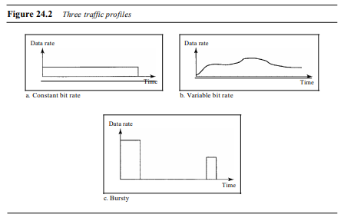

***Congestion***

An important issue in a packet-switched network is congestion. Congestion in a network may occur if the load on the network-the number of packets sent to the network-is greater than the capacity of the network-the number of packets a network can handle.

Congestion in a network or internetwork occurs because routers and switches have queues-buffers that hold the packets before and after processing.

**Congestion control** refers to the mechanisms and techniques to control the congestion and keep the load below the capacity by either preventing congestion, before it happens, or remove congestion, after it has happened.

Two kinds:

**Open-loop congestion control (prevention)**

In open-loop congestion control, policies are applied to prevent congestion before it happens. In these mechanisms, congestion control is handled by either the source or the destination. Brief list of policies given in figure 24.5

**Closed-loop congestion control (removal)**

Closed-loop congestion control mechanisms try to alleviate congestion after it happens. Several mechanisms have been used by different protocols. Some are given below in figure 24.5

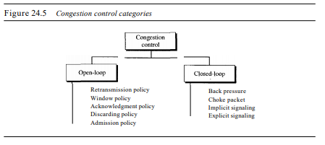

***Quality of Service***

Quality of service (QoS) is an internetworking issue that has been discussed more than defined. We can informally define quality of service as something a flow seeks to attain.

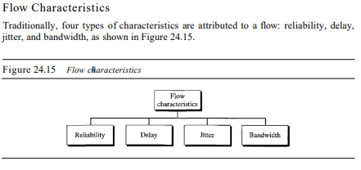

**Reliability** is a characteristic that a flow needs. Lack of reliability means losing a packet or acknowledgment, which entails retransmission. However, the sensitivity of application programs to reliability is not the same.

**Delay**: Source-to-destination delay is another flow characteristic. Applications can tolerate delay in different degrees.

**Jitter** is the variation in delay for packets belonging to the same flow.

**Bandwidth:** Different applications need different bandwidths.

***TECHNIQUES TO IMPROVE QoS***

1. **Scheduling**: Packets from different flows arrive at a switch or router for processing. A good scheduling technique treats the different flows in a fair and appropriate manner. Several scheduling techniques are designed to improve the quality of service.

**Three types: FIFO queuing, priority queuing, and weighted fair queuing.**

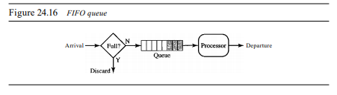

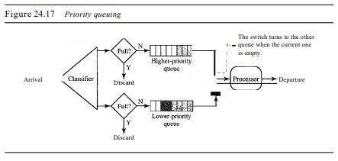

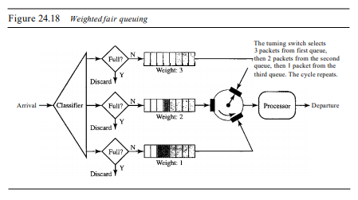

1. **Traffic shaping:** is a mechanism to control the amount and the rate of the traffic sent to the network. Two techniques can shape traffic:   
   **leaky bucket and token bucket.**

**Leaky Bucket** If a bucket has a small hole at the bottom, the water leaks from the bucket at a constant rate as long as there is water in the bucket. The rate at which the water leaks does not depend on the rate at which the water is input to the bucket unless the bucket is empty. The input rate can vary, but the output rate remains constant.

**A leaky bucket algorithm shapes bursty traffic into fixed-rate traffic by averaging the data rate. It may drop the packets if the bucket is full.**

**Token Bucket** The leaky bucket is very restrictive. It does not credit an idle host. For example, if a host is not sending for a while, its bucket becomes empty. Now if the host has bursty data, the leaky bucket allows only an average rate. The time when the host was idle is not taken into account. On the other hand, the token bucket algorithm allows idle hosts to accumulate credit for the future in the form of tokens. For each tick of the clock, the system sends n tokens to the bucket. The system removes one token for every cell (or byte) of data sent.

**The token bucket allows bursty traffic at a regulated maximum rate.**

1. **Resource Reservation:** A flow of data needs resources such as a buffer, bandwidth, CPU time, and so on. The quality of service is improved if these resources are reserved beforehand. We discuss in this section one QoS model called Integrated Services, which depends heavily on resource reservation to improve the quality of service.
2. **Admission Control:** refers to the mechanism used by a router, or a switch, to accept or reject a flow based on predefined parameters called flow specifications. Before a router accepts a flow for processing, it checks the flow specifications to see if its capacity (in terms of bandwidth, buffer size, CPU speed, etc.) and its previous commitments to other flows can handle the new flow.